Assignment on 23rd July:

Activity3.java -> File name

-------------------------------------------------------------------

class Activity3 {

public static void main(String args[]) {

double seconds = 1000000000;

double EarthSeconds = 31557600;

double MercurySeconds = 0.2408467;

double VenusSeconds = 0.61519726;

double MarsSeconds = 1.8808158;

double JupiterSeconds = 11.862615;

double SaturnSeconds = 29.447498;

double UranusSeconds = 84.016846;

double NeptuneSeconds = 164.79132;

System.out.println("Age on Mercury: " + seconds / EarthSeconds / MercurySeconds);

System.out.println("Age on Venus: " + seconds / EarthSeconds / VenusSeconds);

System.out.println("Age on Earth: " + seconds / EarthSeconds);

System.out.println("Age on Mars: " + seconds / EarthSeconds / MarsSeconds);

System.out.println("Age on Jupiter: " + seconds / EarthSeconds / JupiterSeconds);

System.out.println("Age on Saturn: " + seconds / EarthSeconds / SaturnSeconds);

System.out.println("Age on Uranus: " + seconds / EarthSeconds / UranusSeconds);

System.out.println("Age on Neptune: " + seconds / EarthSeconds / NeptuneSeconds);

}

}

Output:

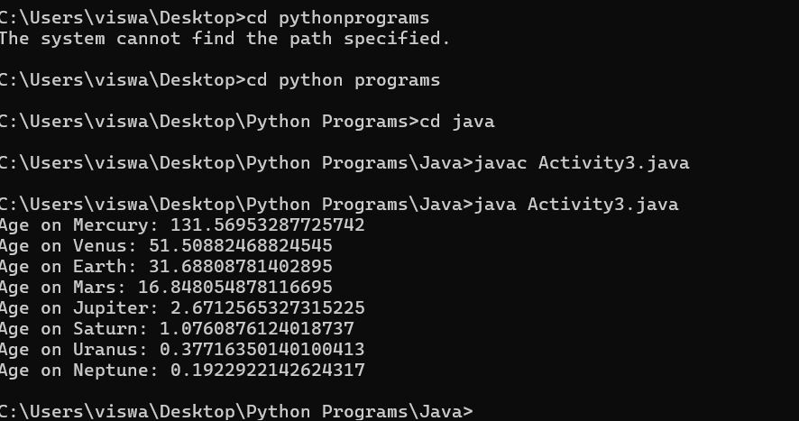

Activity 4:

Activity4.java -> Filename

import java.util.\*;

class Activity4 {

static void insertionSort(int array[]) {

int size = array.length, i;

for (i = 1; i < size; i++) {

int k = array[i];

int j = i - 1;

while (j >= 0 && k < array[j]) {

array[j + 1] = array[j];

j--;

}

array[j + 1] = k;

}

}

public static void main(String args[]) {

int[] data = { 16, 12, 25, 1, 10 };

insertionSort(data);

System.out.println("Sorted Array in Ascending Order: ");

System.out.println(Arrays.toString(data));

}

}

Output:

